

D&E

MEMO

To: | DA2018 - 1111 file
cc:
From | Pat Galbraith-Robertson
Date: | 4 November 2020 | Our ref: | 10.2018.1111.1
Subject: | Additional supporting floor space ratio assessment details

Advice provided to Planning Panel’s Secretariat on 4 November 2020:

Advised that there has been an administrative error made with the below documents unfortunately not being uploaded to the NSW Government Planning Portal.

The correct amended floor space ratio (FSR) plans and calculations have been considered in the Council Assessment Report however the correct amended plan and supporting calculations submitted by the Applicant are required to be uploaded to the Planning Portal, These documents are also recommended to be made publicly available on the Planning Panel’s website.

The Panel should also disregard the following other 3 x attachments of GFA calcs currently attached to agenda on the Panel’s website:

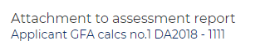

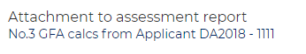
With regard to the assessment report, the FSR commentary is considered to be correct as the 2:1 assessment comment has been made as it was considered appropriate to round up the FSR to the nearest whole digit from 1.9982:1 to 2:1.


Patrick Galbraith-Robertson
Development Planning Coordinator

4 November 2020

